

CSA0501-DATABASE MANAGEMENT SYSTEMS

LAB EXPERIMENTS DATE: 27/07/2026

EXPERIMENT 11-- DATABASE WITH AUTO_INCREMENT SEQUENCES

AIM:
To create and demonstrate an AUTO_INCREMENT sequence for generating register numbers in a database table.

PROCEDURE:

Open MySQL Workbench and select the required database.

Use the existing student_cgpa table containing student details and manually entered register numbers.

Create a new table student_cgpa_auto with reg_no defined as AUTO_INCREMENT.

Insert student records without specifying the register number.

Display the table and observe that MySQL automatically generates sequential register numbers.

Manually populate register numbers in the existing student_cgpa table.

Remove the AUTO_INCREMENT property from student_cgpa_auto using ALTER TABLE.

Display the table structure using DESC to verify the changes.

PROGRAM:

1. CREATE TABLE

CREATE TABLE student_cgpa (
reg_no VARCHAR(15) PRIMARY KEY,
student_name VARCHAR(50) NOT NULL,
department VARCHAR(20),
no_of_subs_pass INT,
no_of_subs_fail INT,
cgpa DECIMAL(3,2)
);
Then Insert Values:
INSERT INTO student_cgpa
(reg_no, student_name, department, no_of_subs_pass, no_of_subs_fail, cgpa)
VALUES
('192411123','Deepthi','CSE',22,2,8.71),
('192512121','Varun','IT',27,1,9.23),
('192312117','Aadhya','ECE',25,3,8.97),
('192411227','Dimple','CSE',31,0,9.37),
('192820896','Mohan','EEE',18,9,6.48),
('192411122','Yogitha','CSE',31,1,9.01),
( '192516871','Sadhya','IT',25,5,7.22),
('192111101','Rahul','MECH',30,12,5.14),
('192411010','Alekhya','CSE',35,2,9.01),
('192511135','Rahul','CIVIL',37,0,9.72);

SELECT * FROM student_cgpa;

OUTPUT:

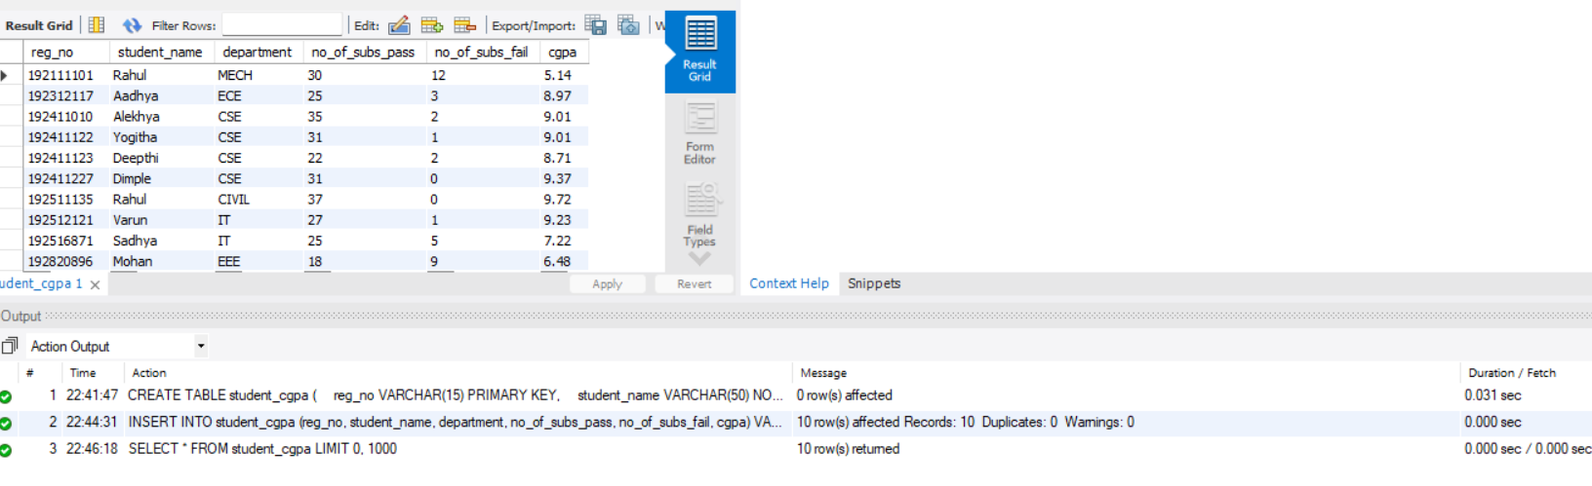

2. Create AUTO_INCREMENT Table

CREATE TABLE student_cgpa_auto (
reg_no INT AUTO_INCREMENT PRIMARY KEY,
student_name VARCHAR(50),
department VARCHAR(20),
no_of_subs_pass INT,
no_of_subs_fail INT,
cgpa DECIMAL(3,2)
);
OUTPUT:

3. Populate Register Number Using AUTO_INCREMENT

INSERT INTO student_cgpa_auto
(student_name, department, no_of_subs_pass, no_of_subs_fail, cgpa)
VALUES
('Deepthi','CSE',22,2,8.71),
('Varun','CSE',27,1,9.23),
('Aadhya','ECE',25,3,8.97),
('Dimple','CSE',31,0,9.37),
('Mohan','EEE',18,9,6.48);
SELECT * FROM student_cgpa_auto;

OUTPUT:

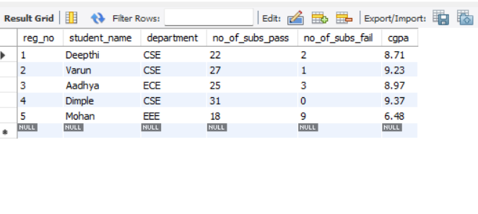

4. Manually Populate Register Number

existing student_cgpa table already demonstrates manual register number entry.

SELECT reg_no, student_name, department
FROM student_cgpa;

OUTPUT:

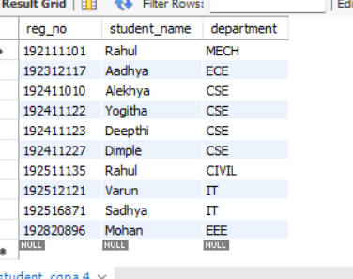

5. Drop the AUTO_INCREMENT

ALTER TABLE student_cgpa_auto
MODIFY reg_no INT NOT NULL;
DESC student_cgpa_auto;

OUTPUT:

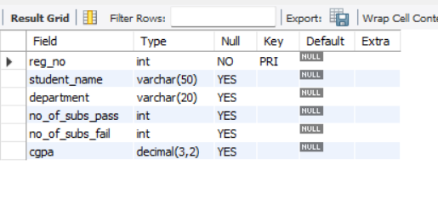

RESULT: Thus, the AUTO_INCREMENT sequence was successfully created and demonstrated for generating register numbers automatically.

